**COVID COMPANION**

**Submitted in partial fulfillment of the requirements of the degree of**

**B.E. Computer Engineering**

**By**

**Rishika Ahuja 02 182008**

**Ann Zachariah 07 182001**

**Aishwarya John 37 182044**

**Anashwara Kurien 44 182051**

**Guide:**

**Mrs. Jayashri Mittal**

**Assistant Professor**



**Department of Computer Engineering**

**St. Francis Institute of Technology**

**(Engineering College)**

**University of Mumbai**

**2021-2022**

**CERTIFICATE**

This is to certify that the project entitled “Covid Companion” is a bonafide work of “ Rishika Ahuja(02), Ann Zachariah(07), Aishwarya John(35), Anashwara Kurien(42) ” submitted to the University of Mumbai in partial fulfillment of the requirement for the award of the degree of B.E. in Computer Engineering



**(Mrs. Jayashri Mittal)**

**(Name and sign)**

**Head of Department**

**Project Report Approval for B.E.**

**This project report entitled (*Covid Companion*) by (*Rishika Ahuja, Ann Zachariah, Aishwarya John, Anashwara Kurien*) is approved for the degree of *B.E. in Computer Engineering.***

**Examiners**

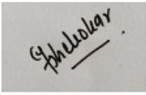

1. **Dr. Narendra M. Shekokar**



1. **Mrs. Jayashri Mittal**

**Date: 29-10-2021**

**Place: Mumbai**

**Declaration**

I declare that this written submission represents my ideas in my own words and where others' ideas or words have been included, I have adequately cited and referenced the original sources. I also declare that I have adhered to all principles of academic honesty and integrity and have not misrepresented or fabricated or falsified any idea/data/fact/source in my submission. I understand that any violation of the above will be cause for disciplinary action by the Institute and can also evoke penal action from the sources which have thus not been properly cited or from whom proper permission has not been taken when needed.

**Rishika Ahuja 02**

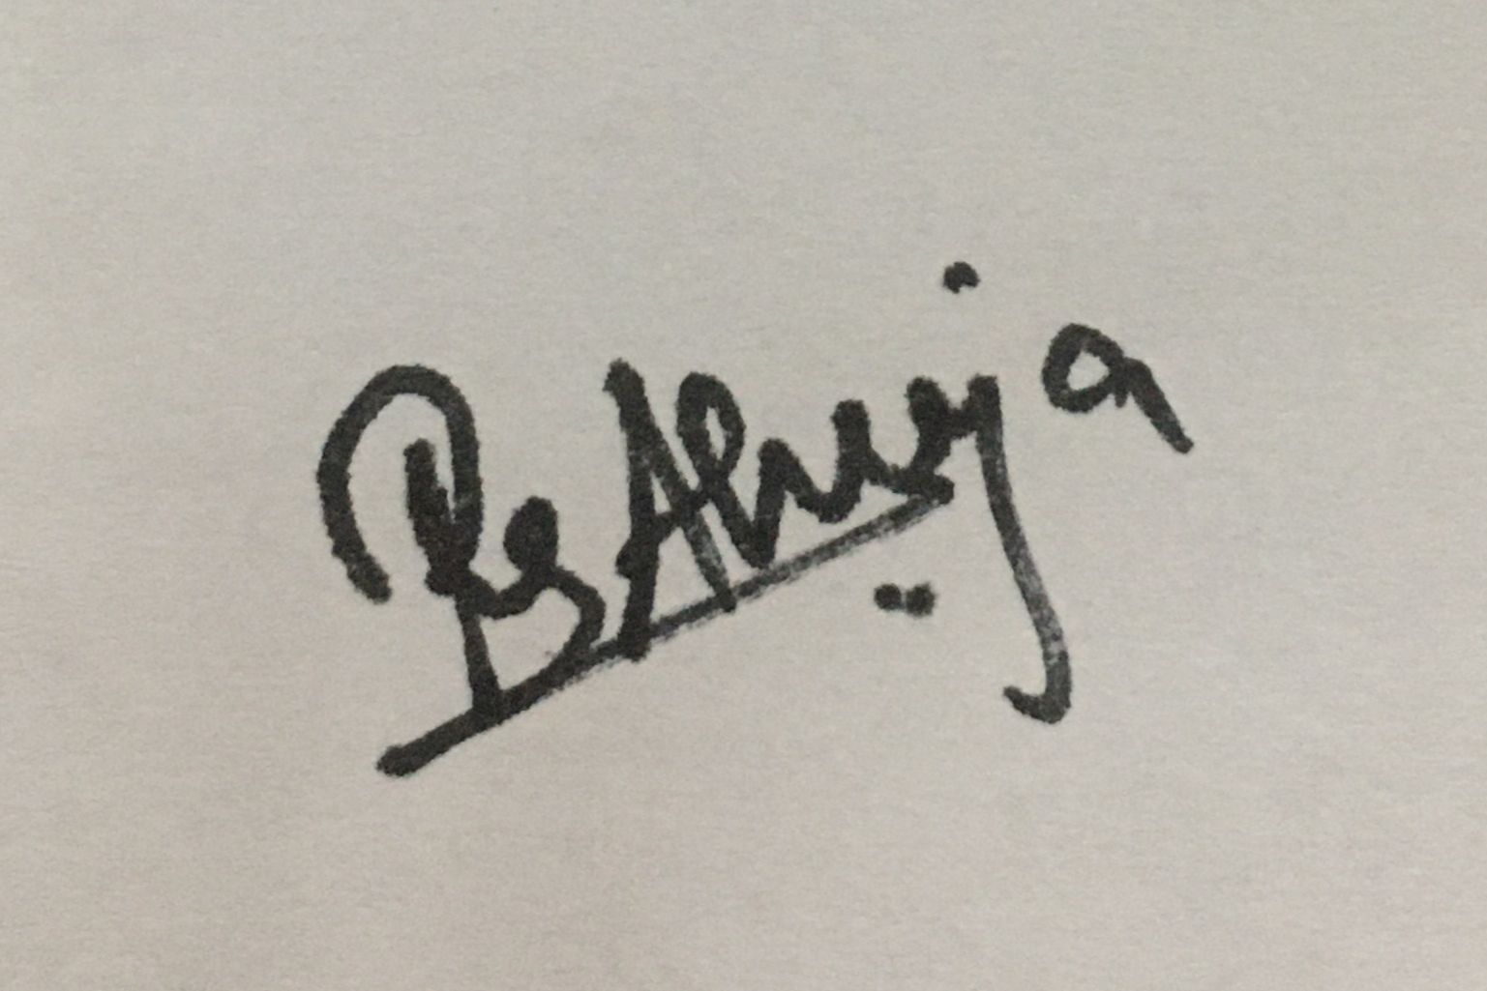

**Ann Zachariah 07**



**Aishwarya John 37**



**Anashwara Kurien 44**



iii

|  |  |
| --- | --- |
|  |  |

**Abstract**

The COVID-19 outbreak, declared as a pandemic by the World Health Organization (WHO), rapidly spread across the globe spreading havoc in its wake. Having suddenly distorted each and every person's routine lifestyle, this pandemic has induced a considerable degree of fear, worry and concern in the population at large. COVID-19 is putting our mental health at risk since it has been proven stressful for plenty of people. Mental health includes our emotional, psychological, and social well-being. It affects how we think, feel, and act. It also helps determine how we handle stress, relate to others, and make healthy choices. Being social beings, humans were not meant to live in isolation. Community is critical for us to thrive, especially for someone with mental illness who is already experiencing the common symptoms of loneliness and isolation.Thus there has been an exponential increase in the number of people suffering from mental disorders with the pandemic taking over the globe.

In this project we have tried to quantify the effect of COVID-19 on the mental health of the users of our system and then suggest to them some basic ways to help them cope with it.

iv

**CONTENT**

| **Chapter** | **Contents** | **Pg**  **No.** |
| --- | --- | --- |
| **1** | **INTRODUCTION:** Give at least two to three sentences about your project. |  |
|  | **1.1 Description *(Brief description of project)*** The main functionality of the project should be explained in brief |  |
|  | **1.2 Problem Formulation *(Explain the problem)*** |  |
|  | **1.3 Motivation *(need of the project)***: List the various approaches along with its drawbacks for solving the problem and briefly explain the approach used for your project. |  |
|  | **1.3 Proposed Solution:** Explain the method/techniques used for solving the problem and how it overcomes the drawbacks mentioned under heading 1.3. Also explain how the project is going to help end users. |  |
|  | **1.4 Scope of the project *(scale/range of your project)*:** Extent of how far your project can be completed. This can be in terms of domain or application related constraints/limitations. |  |
| **2** | **REVIEW OF LITERATURE *(include at least 3IEEE or similar reputed technical papers as reference*)** Should be atleast 2 pages which gives the ideas referenced by the reference papers. Mark the references wherever appropriate. (Note: - Please don’t write the paper titles and the abstract of papers.) |  |
| **3** | **SYSTEM ANALYSIS** |  |
|  | **3.1Functional Requirements*( write requirements of the project)*** Should follow the IEEE SRS format |  |
|  | **3.2 Non Functional Requirements :** Should follow the IEEE SRS format |  |
|  | **3.3 Specific Requirements *(Hardware and software requirements)*** |  |
|  | **3.4 Use-Case Diagrams and description**  (Application development projects use-case is mandatory) |  |
| **4** | **ANALYSIS MODELING** |  |
|  | **4.1 Data Modeling *(E-R Model if any with its associated Data dictionary****)* Applicable for those applications which are dependent on data storage and retrieval. ER Diagram normalized till the third normal form accompanied by the respective data dictionary table should be included |  |
|  | **4.2Activity Diagrams / Class Diagram:** Depending on the type of your project you may include any of the diagrams**.** |  |
|  | **4.3 Functional Modeling (DFDs *with specifications)****mandatory for all projects* |  |
|  | **4.4 TimeLine Chart*(For the entire year)*** |  |
| **5** | **DESIGN** |  |
|  | **5.1 Architectural Design (*Project Flow /architecture with description)*** |  |
|  | **5.2 User Interface Design** GUI for your project |  |
| **6** | **IMPLEMENTATION** |  |
|  | **6.1 Algorithms / Methods Used**  Mention your algorithms if any or any methodology used in detail along with the examples . |  |
|  | **6.2 Working of the project *(code for mentioned algorithms)*** |  |
| **7** | **TESTING *(white box /black-box / any testing algorithm used)*** |  |
|  | **7.1 Test cases *(conditions on which testing is done)*** |  |
|  | **7.2 Type of Testing used *(explanation and reason of testing method used)*** |  |
| **8** | **RESULTS AND DISCUSSIONS *(final results or outputs)*** |  |
| **9** | **CONCLUSIONS&FUTURE SCOPE** |  |

Appendix

Literature Cited

Publications by your group (if any)

Acknowledgements

vi

**List of Figures**

| **Fig. No.** | **Figure Caption** | **Page No.** |
| --- | --- | --- |
|  |  |  |
|  |  |  |
|  |  |  |
|  |  |  |
|  |  |  |
|  |  |  |
|  |  |  |

vii

**List of Tables**

| **Table No.** | **Table Title** | **Page No.** |
| --- | --- | --- |
|  |  |  |
|  |  |  |
|  |  |  |
|  |  |  |
|  |  |  |
|  |  |  |
|  |  |  |

viii

**List of Abbreviations**

| **Sr. No.** | **Abbreviation** | **Expanded form** |
| --- | --- | --- |
| i | DSS | Decision Support System |
| ii | CAS | Covid Anxiety Scale |
|  |  |  |
|  |  |  |
|  |  |  |
|  |  |  |
|  |  |  |

ix

1. **INTRODUCTION**

The COVID-19 outbreak, which first emerged in China, has been declared as a pandemic by the World Health Organization (WHO). As the coronavirus pandemic rapidly sweeps across the world, it is inducing a considerable degree of fear, worry and concern in the population at large. COVID-19 is putting our mental health at risk since it has been proven stressful for plenty of people.A person's mental health affects how they handle stress, relate to one another and make decisions.It also influences the way individuals look at themselves, their lives and others in their lives.Studies show that at least 1 in 5 children and adolescents have a mental health disorder at any given time. Yet, fewer than one in five of these children receive the mental health services they need. Among young people, at least 1 in every 10 has a serious emotional disturbance at any given time. We’re social beings, and we are not meant to live in isolation. Community is critical for us to thrive, especially for someone with mental illness who is already experiencing the common symptoms of loneliness and isolation.Thus there has been an exponential increase in the number of people suffering from mental disorders with the COVID-19 pandemic wreaking havoc all over the globe.

Therefore, our project aims to judge the effect of COVID-19 on the mental health of the users and then suggest to them some basic ways to help them cope with it.

**1.1 Description**

As COVID-19 has occurred suddenly and is highly contagious, this will inevitably cause people anxiety, depression, etc. In such times the study on the public psychological states and its related factors during the COVID-19 outbreak is of practical significance. Mental health includes our emotional, psychological, and social well-being. It affects how we think, feel, and act. It also helps determine how we handle stress, relate to others, and make healthy choices. Mental health is important at every stage of life, from childhood and adolescence through adulthood.

Mental health is important because it can help you to cope with the stresses of life,be physically healthy,have good relationships,make meaningful contributions to your community,work productively and realize your full potential.Mental health is also important because it can affect physical health. For example, mental disorders can raise your risk for physical health problems such as [stroke](https://medlineplus.gov/stroke.html), [type 2 diabetes](https://medlineplus.gov/diabetestype2.html), and [heart disease](https://medlineplus.gov/heartdiseases.html). Over time,mental health can change when one may be dealing with a difficult situation, such as the current COVID-19 scenario. The situation may wear a person out and overwhelm their ability to cope with it. This can worsen their mental health.This project is aimed at tackling the sudden downgrading of mental health of the general population that is brought about by the onset of the global pandemic. It has a huge societal impact and is the need of the hour.

**1.2 Problem Definition**

To create a companion system for an individual which helps to analyze the mental health of the being during Covid-19 pandemic and provides precise suggestions based on their mental condition.

**1.3 Motivation**

With the sudden outbreak of COVID-19 which caused complete closure of schools, colleges, work and social life in general and the infectious power of the virus, it is inevitable to see a drastic rise in anxiety, depression and other stress reactions. With the new limitations on daily life and social activities for an unknown period of time, the population will inevitably suffer from stress and anxiety and eventually may lose confidence in life, ultimately taking a toll on the mental health of society. Thus to help every individual through these socially distanced times we decided to take up the project to make a Covid Companion app. An App that will help individuals assess themselves as per their habit inputs if they are likely to have any sort of mental health problems and thus suggest a solution to help cope through the problems in ways that may bring significant changes to one’s daily lives.

**1.4 Problem Solution**

In this project, a model is prepared based on the dataset which contains the mental health information of people during the Covid-19 pandemic. The dataset is cleaned and processed using the appropriate algorithms and the relevant features from the dataset are selected which helps in training the model. The model then forms the basis for the COVID Companion app. The user's features are collected in the app and given to the previously trained model. The mental health of the user is analyzed and suggestions are given which help to improve the mental health of the user.

**1.5 Scope of the Project**

This project aims to increase the mental wellbeing of the users and reduce their depressive symptoms. We aim to increase mental health awareness among the general public and help them cope with the stress and hardships caused by the sudden onset of this pandemic. Mental health awareness increases the chances for early intervention, which can result in a fast recovery. Awareness reduces negative adjectives that have been set to describe our people with a mental illness. By raising awareness, mental health can now be seen as an illness. These illnesses can be managed by treatment. [Mental disorders](https://medlineplus.gov/mentaldisorders.html) are serious conditions which can affect your thinking, mood, and behavior. They may be occasional or long-lasting. They can affect your ability to relate to others and function each day. But there are treatments. People with mental disorders can get better, and many of them recover completely. Our project hopes to build an app that proves to be a worthy companion to the mental health of those suffering in these hard times by helping them access the state of their mental well being and providing simple measures to help them cope with it and begin their journey on the path of recovery.

1. **Review of Literature**

**Paper 1**

**Title:** Study on the public psychological states and its related factors during the outbreak of coronavirus disease 2019 (COVID-19) in some regions of China

**Data:**

600 valid questionnaires were received. The Self-Rating Anxiety Scale (SAS) and the Self-Rating Depression Scale (SDS) were used.

A total of 605 psychological state questionnaires were distributed to the general population through online questionnaires from February 6 to 9, 2020. 600 valid questionnaires were received, and the response rate was 99.17%.600 valid answers, resulting in a 100% effective rate. Inclusion criteria include the following: (1) 18 years old and above and (2) completed questionnaire. Exclusion criteria include the following: (1) 17 years old and below and (2) questionnaire responses are not logical.

**Method:**

In this study, the Self-Rating Anxiety Scale (SAS) and the Self-Rating Depression Scale (SDS)were used.

The Self-Rating Scale questionnaire was completed by the following survey items according to the unified guidance methods. The contents include the following: (1) General information includes name, gender, age, education level, occupation and residence; (2) SAS is used to evaluate the subjective feelings of anxiety; and (3) SDS is used to measure the degree of depression.

The two independent self-assessment scales mainly assess the frequency of symptoms of the respondents in the past week, each with 20 items, using a 4-level score (1 for a little of the time, 2 for some of the time, 3 for a good part of the time and 4 for most of the time).

Standard score = 1.25 × total score.

Anxiety levels were graded as the following: standard score below 50 = non-anxiety; 50–59 = mild anxiety; 60–69 = moderate anxiety; and above 70 = severe anxiety.

Depression levels were graded as the following: standard score below 53 = non-depression; 53–62 = mild depression; 63–72 = moderate depression; and above 73 = severe depression.

The data were organized and analyzed using SPSS 23.0 software. The surveyed population was divided into anxiety groups and non-anxiety groups according to the SAS scoring criteria. According to the SDS scoring standard, the surveyed population was divided into depression groups and non-depression groups.

The analysis of the relationship between gender, age, education level, occupation, region and anxiety or depression initially used the chi-square test. The variables with p < 0.1 were entered in the multiple logistic regression analysis model. The correlation between SAS and SDS standard scores was analyzed by Spearman correlation analysis, and p < 0.05 on double sides was statistically significant.

**Algorithm:**Logistic Regression

**PAPER 2**

**Title:** COVIDiSTRESS Global Survey dataset on psychological and behavioral consequences of the COVID-19 outbreak

**Authors:** Yuki Yamada, Dominik-Borna Ćepulić, Tao Coll-Martín, Stéphane Debove, Guillaume Gautreau, Hyemin Han,Jesper Rasmussen, Thao P. Tran, Giovanni A. Travaglino, COVIDiSTRESS Global Survey Consortium & Andreas Lieberoth

**Data:**

This N = 173,426 social science dataset was collected through the collaborative COVIDiSTRESS Global Survey – an open science effort to improve understanding of the human experiences of the 2020 COVID-19 pandemic between 30th March and 30th May, 2020.

The dataset contains demographic background variables as well as measures of Asian Disease Problem, perceived stress (PSS-10), availability of social provisions (SPS-10), trust in various authorities, trust in governmental measures to contain the virus (OECD trust), personality traits (BFF-15), information behaviours, agreement with the level of government intervention, and compliance with preventive measures, along with a rich pool of exploratory variables and written experiences

**Method:**

3,426 people accessed an online survey link to provide their experiences over a period of 62 days (30th March to 30th May. The stored dataset represents 125,306 people who met inclusion criteria (18 years of age and older and gave informed consent)

**Paper 3**

**Title:** Coronavirus Anxiety Scale: A brief mental health screener for COVID-19 related anxiety

**Authors:** Sherman A. Lee

**Abstract:**

As the coronavirus pandemic rapidly sweeps across the world, it is inducing a considerable degree of fear, worry and concern in the population at large and among certain groups in particular, such as older adults, care providers and people with underlying health conditions. In public mental health terms, the main psychological impact to date is elevated rates of stress or anxiety which has not been adequately addressed. But as new measures and impacts are introduced – especially quarantine and its effects on many people’s usual activities, routines or livelihoods – levels of loneliness, depression, harmful alcohol and drug use, and self-harm or suicidal behavior are also expected to rise.

**Data:**

The dataset was created through an online survey and a total of 775 adults took that survey from 11-30 March 2020 out of which 446 men and 329 women with a combined mean age of 32.72 years. Participants were asked to report their age, gender, ethnicity, education, current residency, coronavirus diagnosis, and history of anxiety. Because the study focused on anxiety about the coronavirus, participants also had to have spent at least one hour during the past two weeks thinking about and/or watching media about the coronavirus, as well as have experienced significant anxiety, fear, or worry about the disease outbreak.

For the survey, participants were asked to choose, using a 5-point time anchored scale (0=not at all to 4=nearly every day over 2 weeks), the rating of “2” as the item response. This item was embedded into the questionnaire to eliminate participants who may threaten the integrity of the study’s results by not appropriately attending to the questionnaire’s content. The objective of this study was to develop and evaluate the properties of the Coronavirus Anxiety Scale (CAS), which is a brief mental health screener to identify probable cases of dysfunctional anxiety associated with the COVID-19 crisis.

**Methods Used:**

In this study Coronavirus Anxiety Scale was used to identify cases of dysfunctional anxiety. This 5-item scale, which was based on 775 adults with anxiety over the coronavirus, demonstrated solid reliability and validity. A pool of 20 candidate items was created based on the psychology of fear and anxiety literature where each item captures a unique manifestation of this particular form of anxiety that includes cognitive (i.e., repetitive thinking; worry; processing biases; dreaming; planning), behavioral (i.e., dysfunctional activities; avoidance; compulsive behaviors), emotional (i.e., fear; anxiety; anger), and physiological (i.e., sleep disturbances; somatic distress; tonic immobility;) dimensions of coronavirus anxiety.

To address the influences of sampling error, an internal replicability approach was employed by subjecting one half of the study's data to a principal component analysis and the other half to a series of confirmatory factor analyses using bias-corrected bootstrap Maximum Likelihood estimations. The PCA was used to identify the five most robust and representative symptoms of coronavirus anxiety, while a confirmatory factor analysis CFA was used to test replicability of the PCA results. The entire data set was then used to examine the construct validity and diagnostic viability of the coronavirus anxiety symptoms using a series of correlations and receiver operating characteristic (ROC) analyses, respectively.

Properties of the CAS items from the principal components analysis are dizziness, sleep disturbances, tonic immobility, appetite loss and abdominal distress. These symptoms had to be extracted from the first component of the PCA because they account for the highest possible squared correlations among the item pool.

Twenty coronavirus anxiety symptoms were subjected to a PCA with Varimax rotation with the first component accounting for 59.85% of total variance. Specifically, pattern/structure coefficients ranged from 0. 81 to 0. 84, communality coefficients ranged from 0. 74 to 0. 79, and cross-loadings ranged from 0. 23 to 0.29. These symptoms assess distinct, physiological reactions of fear and anxiety related to the coronavirus and are highly reliable as a cluster.

CFA was run to test whether or not the five symptoms identified in the previous PCA cohered together into a single, coronavirus anxiety construct where multigroup CFAs were run to examine if the coronavirus anxiety construct was being measured the same way across the demographic variables of age (18–29 vs 30 and older), gender (women vs men), and race (Whites vs non-Whites). Analysis of the parameter estimates revealed that sleep disturbances and appetite changes were much stronger indicators of the coronavirus anxiety construct for Whites than for the non-Whites. Although the strength of these two indicators were different between the races, the measurement of coronavirus anxiety was still valid for both groups.

CAS total scores were correlated with measures of disability, distress, and coping, to examine the validity of the construct and explore its relationship with relevant attitudes and demographic factors. CAS scores were strongly, positively correlated with functional impairment, alcohol or drug coping, negative religious coping, extreme hopelessness, and passive suicidal ideation, in support of this instrument’s construct validity as a measure of dysfunctional anxiety.

Receiver operating characteristic analyses were used to evaluate the diagnostic viability of the CAS as a mental health screening tool, as well as determine a cut score that best distinguishes individuals who experience clinically significant impairment because of coronavirus anxiety from those who were also anxious but not disabled by the pandemic. A CAS score 9 for ROC optimally classified adults as having or not having dysfunctional levels of anxiety with a false positive rate of 15%. Thus, these results support the CAS as a diagnostically accurate mental health screening tool with strong classification features.

CAS scores were strongly, positively associated with functional impairment, alcohol or drug coping, negative religious coping, extreme hopelessness, and passive suicidal ideation. The results of this study also support the CAS as a useful mental health screener, as its diagnostic qualities (90% sensitivity and 85% specificity) are comparable to other psychiatric screening tests.

1. **SYSTEM ANALYSIS**

**3.1 Functional Requirements:**

USER INTERFACE: The user interface will be an application that takes input from the user based on a pre-decided Questionnaire. Based on the User inputs the user interface will provide the user with various suggestions as to how to better his/her Mental Health and better cope with the situation.

PROPER PREDICTION: The System should properly predict the degree to which the users mental health is being affected based on the user inputs.

SUGGESTIONS TO IMPROVE MENTAL HEALTH : According to the results of the assessment of the user’s mental health, the system must display accurate suggestions that help improve the user’s mental health.

DATABASE: The database consists of the user’s personal information such as name, age, contact number, marital status, past medical history, etc. The feedback given by the user would be stored in the database and used in order to improve the system. A second database would consist of the names and contact information of a few psychiatrists so that a patient having severe anxiety and mental health issues could be referred to them.

**3.2 Non-Functional Requirements:**

# Platform Independent:

The application would be platform-independent if all the requirements are installed in the device.

# Performance:

The application should have better accuracy and should provide the information in less time.

# Capacity:

The capacity of the storage should be high so that a large amount of data can be stored in order to train the model.

**Performance Requirements**

1. The System should be able to accurately predict the state of the mental health of the user.

2. Once the mental health is assessed the System should be able to display accurate suggestions for the betterment of the user's mental health based on the amount of harm caused to the same.

**Security Requirements:**

Since our project updates automatically, changes should not be made in the dataset by anyone, including the admin or the viewer. In case of a server crash, existing data must not be wiped out. The source code must not be tampered with under normal circumstances with the exception of maintenance or update. The user's details should always stay anonymous under any circumstances.

**Software Quality Attributes**

Availability-1: Once the app is ready it can be available for free downloads on the google play store.

Availability -2: Once the app is installed on the users device it is available for use as and when the user pleases.

Installability-1: The application needs to be installed on the user’s device.

Maintainability-1: For the Updates and Maintenance of the system, the source codes for the system are well documented.

Accurateness-1: The system provides accurate prediction regarding the mental health assessment of the user .

Accurateness-2:The System provides accurate suggestions to the user tailored to suit their mental health needs

Testability-1: The system will not be available if some errors occur for easier debugging.

Usability-1: The system is well designed to allow easy usage and navigation.

Usability-2: The Graphical User Interface of the System provides an option for the user to input values and thereafter provides suggestions based on the particular user’s mental health assessment.

Flexibility-1: The system can be accessed on all android phones.

**3.3 Specific Requirements**

**Hardware Requirements:**

* CPU --Intel Core i5 9300H
* MotherBoard -- Covini_CFS HM370
* Hard Disk Space -- 1TB
* Display -- 1080 FHD 15.6inch
* Memory -- 2666Hz 8gb DDR4 ram
* Other Devices – Laptop

**Software Requirements:**

* Operating System: Windows 10
* Application : Colab Notebook
* Programming Language : Python, HTML, CSS, JS, Bootstrap, PHP

**3.4 Use case Diagram and description**

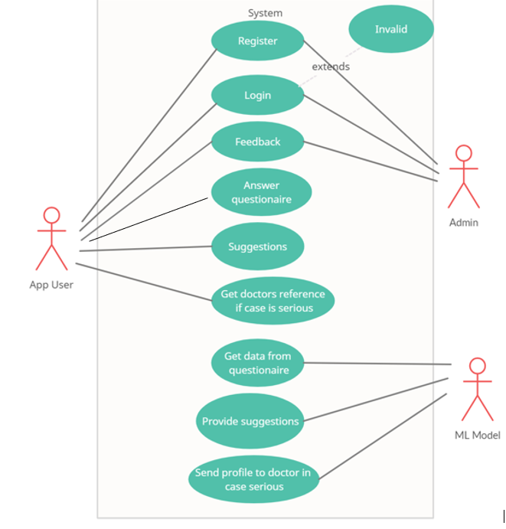

Fig.3.1. Use Case for Covid Companion

In this use case diagram, the app user registers himself into the system. The user can login into the system using the credentials and can answer the questions that are asked by the system. These answers are collected by the system and trained by the model using the valid algorithms. The mental health of the user is calculated and suggestions are given by the model based on the scores generated. If the condition of the user is serious then the model sends the profile of the user to a doctor or psychiatrist.

**Use Case Description:**

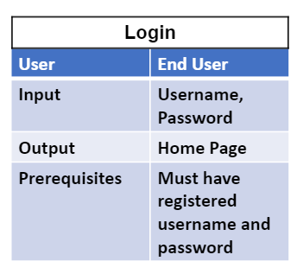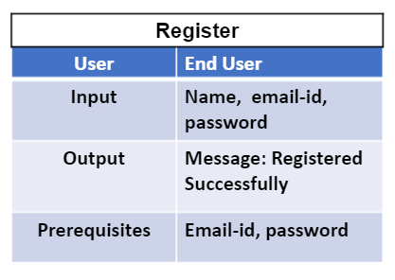

Fig 3.2. Login Fig 3.3. Register

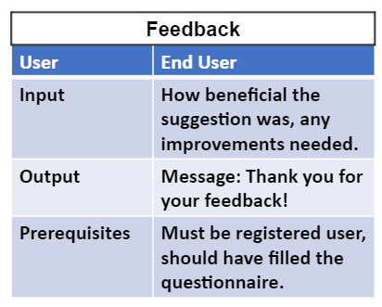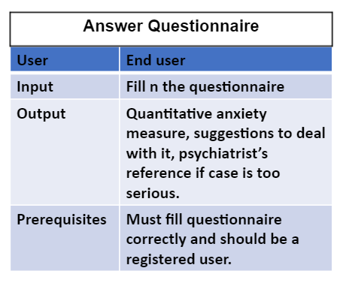

Fig 3.4. Feedback Fig 3.5.. Answer Questionnaire

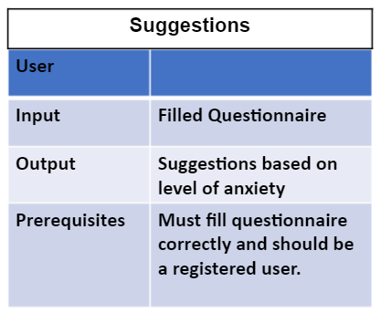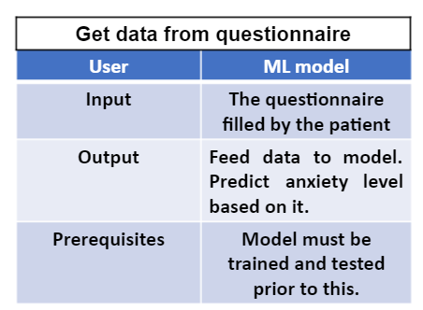

Fig 3.6. Suggestions Fig 3.7. Get data from Questionnaire

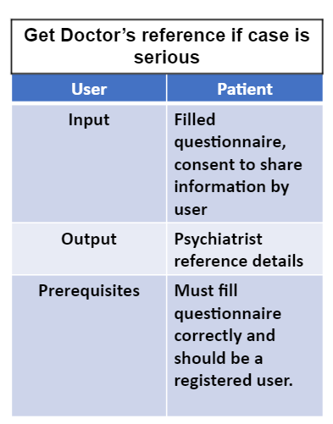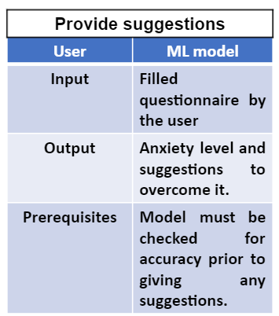

Fig 3.8. Doctors Reference Fig 3.9. Provide suggestions

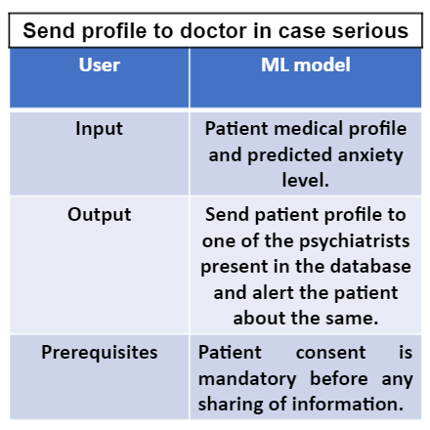

Fig 3.10. Send profile to doctor

1. **ANALYSIS MODELING**

**4.1 Data Modeling**

**4.2 Activity Diagrams / Class Diagram**

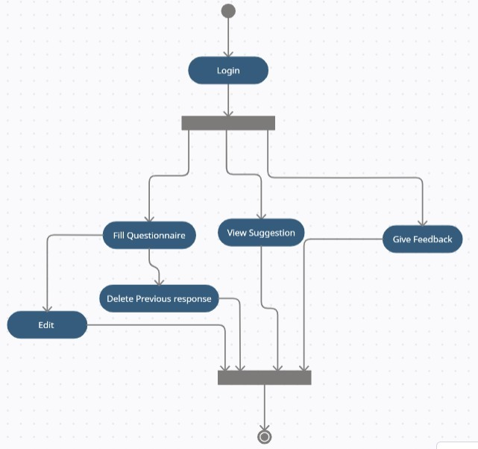

Fig.4.1. Activity Diagram for Covid Companion

**4.2 Functional Modeling**

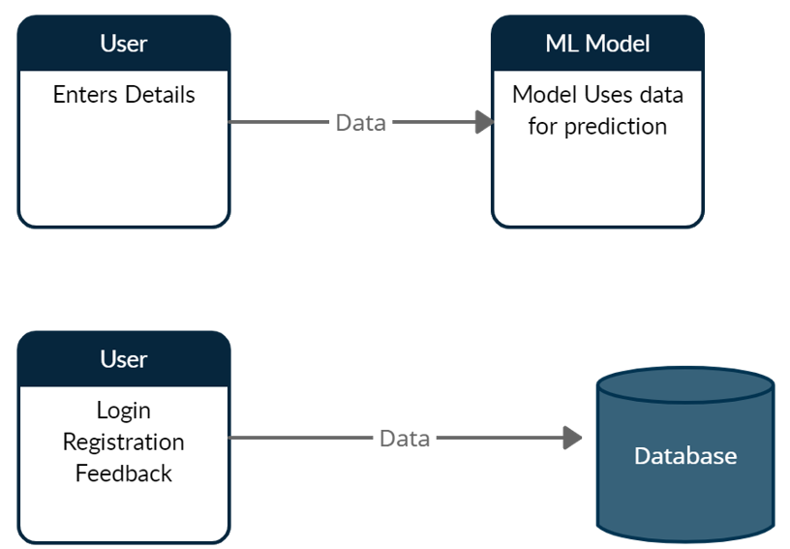

Fig.4.2. DFD

1. **DESIGN**

**5.1 Architecture Design:**

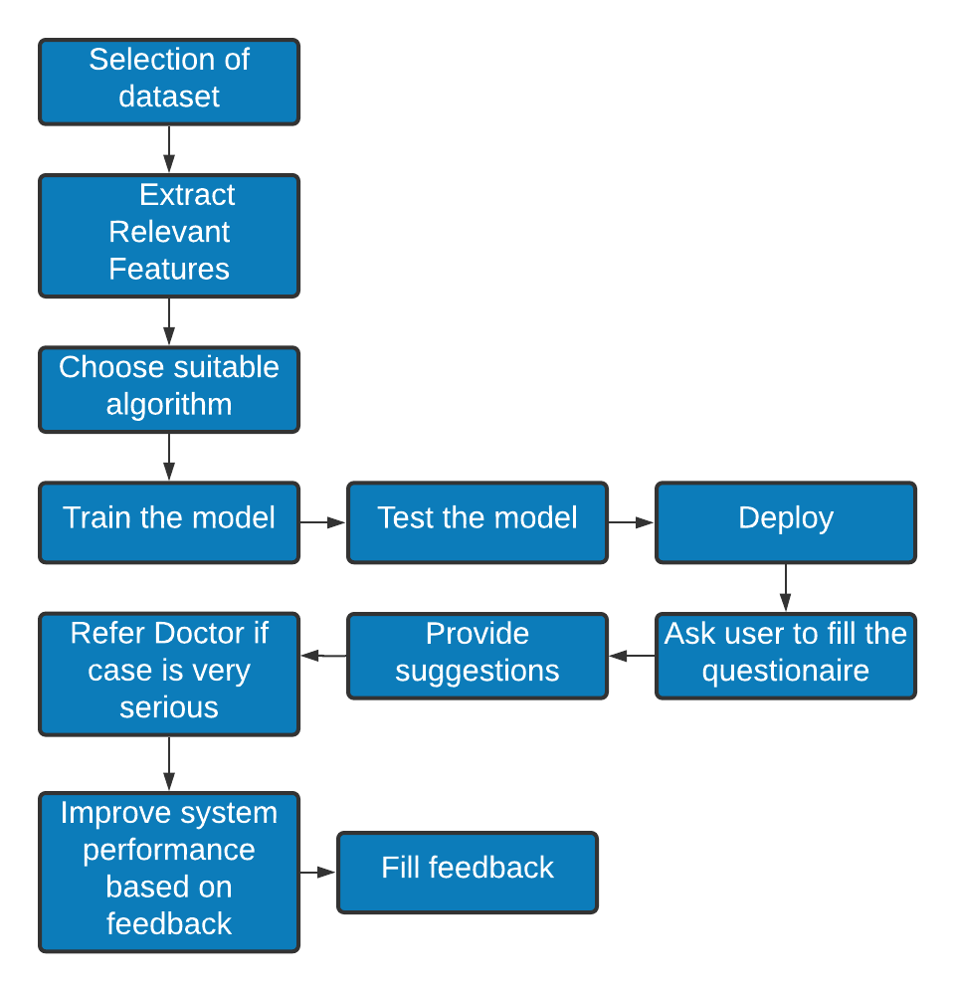

Fig.5.1. Architecture Design for Covid Companion

**5.2 User Interface Design**

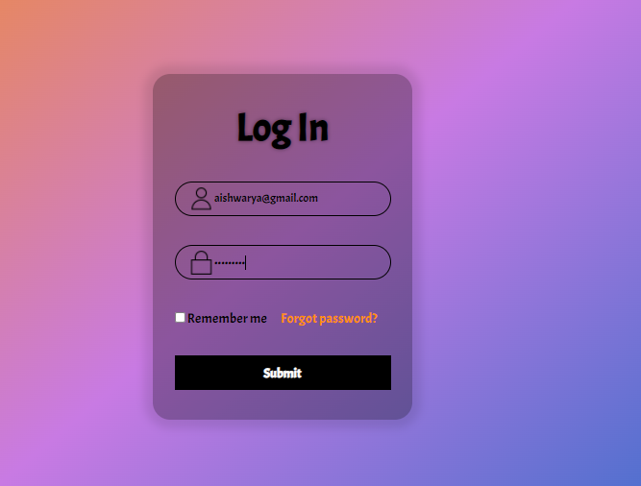



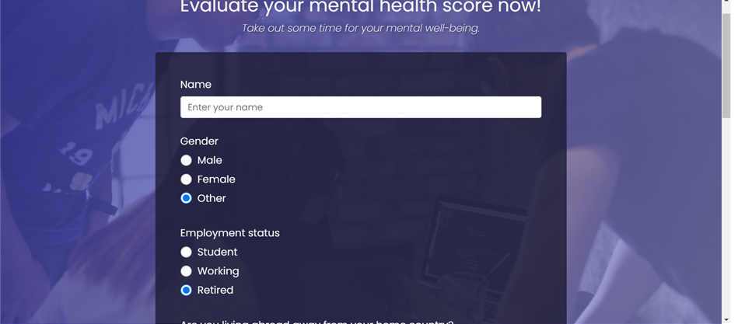

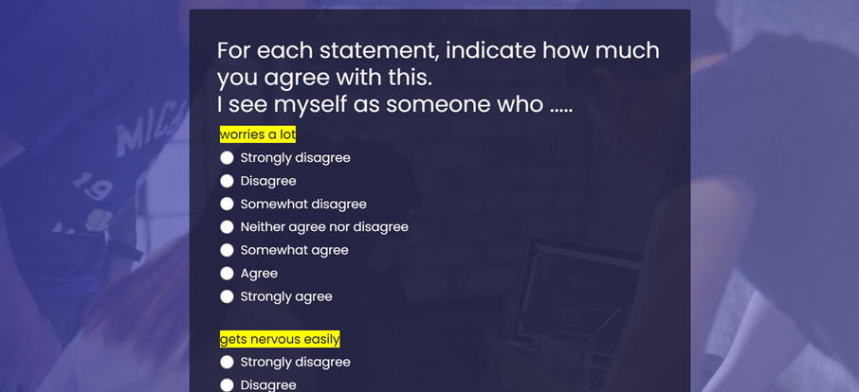

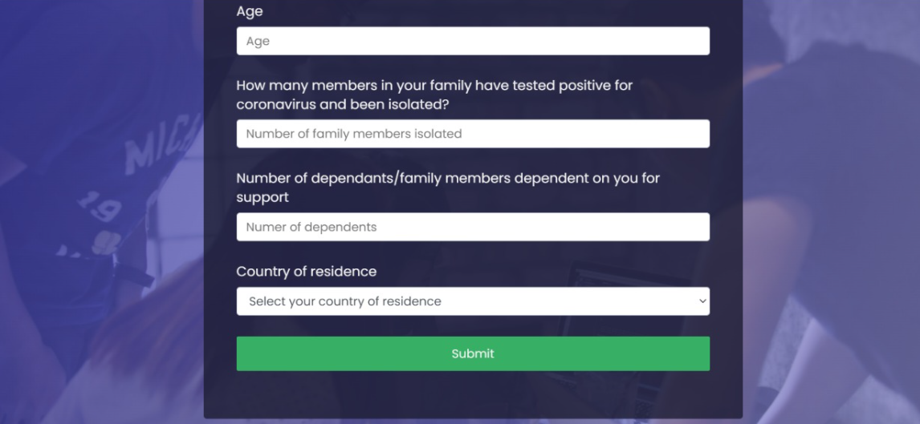

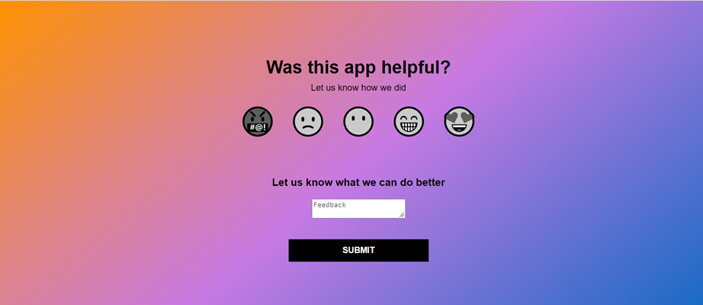

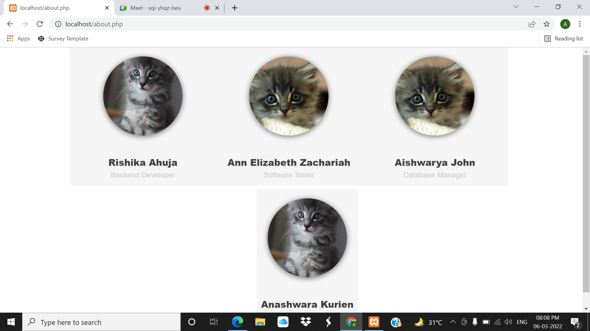

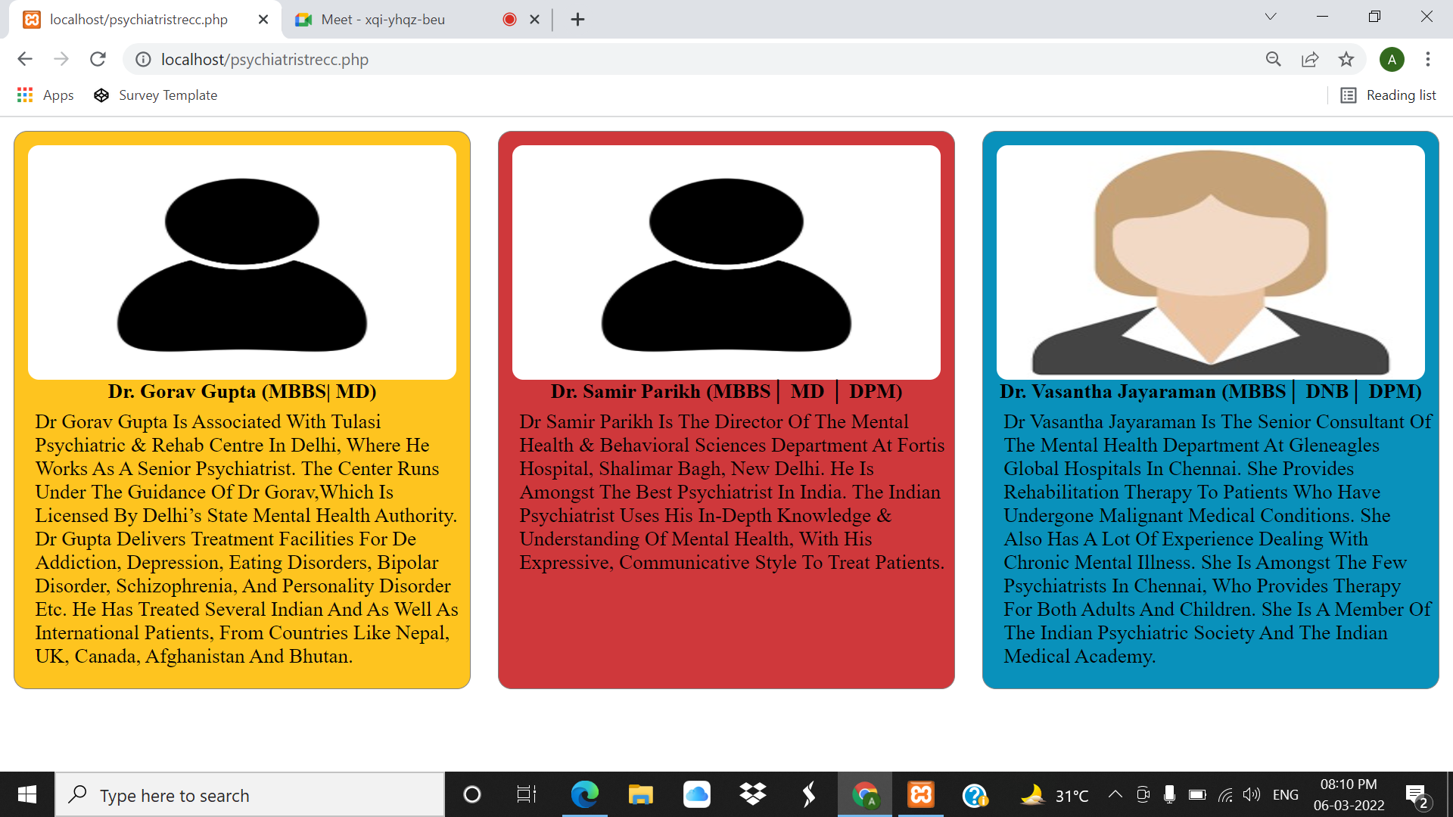

USER INTERFACE: The user interface will be an application that takes input from the user based on a pre-decided Questionnaire. Based on the User inputs the user interface will provide the user with various suggestions as to how to better his/her Mental Health and better cope with the situation.

PROPER FORECASTING: The System should properly predict the degree to which the users mental health is being affected based on the user inputs.

SUGGESTIONS TO IMPROVE MENTAL HEALTH : According to the results of the assessment of the user’s mental health, the system must display accurate suggestions that help improve the user’s mental health.

1. **IMPLEMENTATION**

**6.1 Algorithms / Methods Used:**

**Data Cleaning and Preprocessing:**

* **Null Values were padded to zero**
* **For Feature Selection PCA( Principal Component Analysis) was used:**

The Dataset used for this project has 125306 rows. Large datasets such as this one are often difficult to interpret.

Between Principal component analysis (PCA) and Independent Component Analysis(ICA) we chose PCA as ICA gives rise to underfitting in the model.

PCA is a technique for reducing the dimensionality of such datasets, increasing interpretability but at the same time minimizing information loss. It does so by creating new uncorrelated variables that successively maximize variance. Finding such new variables, the principal components, reduces to solving an eigenvalue/eigenvector problem, and the new variables are defined by the dataset at hand, not a priori, hence making PCA an adaptive data analysis technique.

**Algorithm Proposed:**

Neural Network

A neural network is a series of algorithms that endeavors to recognize underlying relationships in a set of data through a process that mimics the way the human brain operates.

**How Neural Networks Work:** A simple neural network includes an input layer, an output (or target) layer and, in between, a hidden layer. The layers are connected via nodes, and these connections form a “network”– the neural network – of interconnected nodes. A node is patterned after a neuron in a human brain.

**6.2 Working of the Project:**

**PCA:**

1. STEP 1: STANDARDIZATION
2. The aim of this step is to standardize the range of the continuous initial variables so that each one of them contributes equally to the analysis.
3. More specifically, the reason why it is critical to perform standardization prior to PCA, is that the latter is quite sensitive regarding the variances of the initial variables. That is, if there are large differences between the ranges of initial variables, those variables with larger ranges will dominate over those with small ranges (For example, a variable that ranges between 0 and 100 will dominate over a variable that ranges between 0 and 1), which will lead to biased results. So, transforming the data to comparable scales can prevent this problem.

### STEP 2: COVARIANCE MATRIX COMPUTATION

* + 1. The aim of this step is to understand how the variables of the input data set are varying from the mean with respect to each other, or in other words, to see if there is any relationship between them. Because sometimes, variables are highly correlated in such a way that they contain redundant information. So, in order to identify these correlations, we compute the covariance matrix.

### STEP 3: COMPUTE THE EIGENVECTORS AND EIGENVALUES OF THE COVARIANCE MATRIX TO IDENTIFY THE PRINCIPAL COMPONENTS

* + 1. Eigenvectors and eigenvalues are the linear algebra concepts that we need to compute from the covariance matrix in order to determine the *principal components* of the data.

### STEP 4: FEATURE VECTOR

### Computing the eigenvectors and ordering them by their eigenvalues in descending order, allow us to find the principal components in order of significance. In this step, what we do is, to choose whether to keep all these components or discard those of lesser significance (of low eigenvalues), and form with the remaining ones a matrix of vectors that we call *Feature vector*.

### LAST STEP: RECAST THE DATA ALONG THE PRINCIPAL COMPONENTS AXES

* + 1. In the previous steps, apart from standardization, you do not make any changes on the data, you just select the principal components and form the feature vector, but the input data set remains always in terms of the original axes (i.e, in terms of the initial variables).
    2. In this step, which is the last one, the aim is to use the feature vector formed using the eigenvectors of the covariance matrix, to reorient the data from the original axes to the ones represented by the principal components (hence the name Principal Components Analysis). This can be done by multiplying the transpose of the original data set by the transpose of the feature vector.

**7. TESTING**

**7.1 Test Case**

**7.2 Type of Test Used**

**8. RESULT AND DISCUSSIONS**

**9. CONCLUSION**

As COVID-19 has occurred suddenly and is highly contagious, this will inevitably cause people anxiety, depression, etc.In such times the study on the public psychological states and its related factors during the COVID-19 outbreak is of practical significance.Mental health includes our emotional, psychological, and social well-being. It affects how we think, feel, and act. It also helps determine how we handle stress, relate to others, and make healthy choices. Mental health is important at every stage of life, from childhood and adolescence through adulthood.

Since this project is aimed at tackling the sudden downgrading mental health of the general population that is brought about by the onset of the global pandemic it has a huge societal impact and is the need of the hour.

**9. FUTURE SCOPE**

In the future we could develop this application and widen the scope of this project for various other diseases like cancer, cardiovascular problems, etc. We could add into this a module which provides a platform for online consultations with psychiatrists and other physicians.